**Processing whole blood in Smart Tubes**

1. Label Smart Tubes appropriately. Label the side of the tube with a marker and affix a pre-made label to the other side. Secure pre-made label with clear tape to ensure it does not fall off during cryogenic storage.

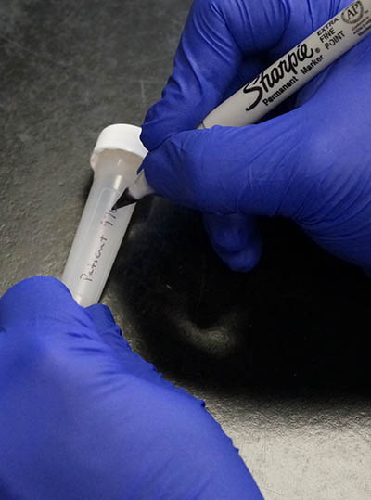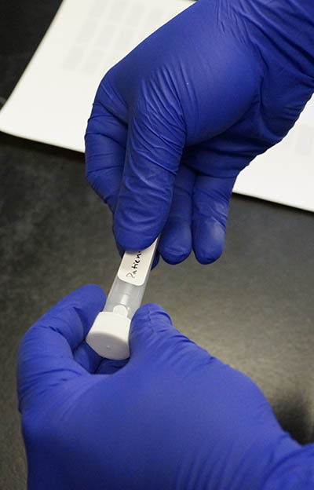

1. Prepare stimulations. Stimulations should be prepared before phlebotomy to avoid delays once the blood is drawn. If diluted stimulations won’t be used within one hour of preparation, store them at 4°C until ready to use.
   1. **Unstim (3 replicates):** 40μL PBS + 360μL RPMI (makes enough for 4 tubes)
   2. **LPS [InvivoGen catalog # tlrl-peklps]:** 1.1μl (1mg/mL stock) + 109μL RPMI
   3. **IFNα [Sigma-Aldrich catalog # I4276]:** 11μL (10μg/mL stock) + 99μL RPMI
   4. **IL-2 [BD Biosciences catalog # 554603]:** 11μL (10μg/mL stock) + 99μL RPMI
   5. **IL-4 [BD Biosciences catalog # 554605]:** 11μL (10μg/mL stock) + 99μL RPMI
   6. **IL-6 [BD Biosciences catalog # 550071]:** 11μL (10μg/mL stock) + 99μL RPMI
   7. **IL-10 [BD Biosciences catalog # 554611]:** 11μL (10μg/mL stock) + 99μL RPMI
   8. **TNFα [R&D Systems catalog # 210-TA-020]:** 11μL (10μg/mL stock) + 99μL RPMI
2. Draw peripheral venous blood into a sodium-heparin blood collection tube (BD catalog # 366480).
3. Store blood at room temperature until ready to process. Process blood within 1 hour of draw (within 30 minutes of draw for best results).

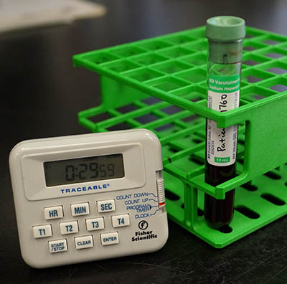

1. Dispense **100μL** of each stimulation into one of each of the Smart Tubes. Final concentrations will be: LPS (1μg/mL), IFNα/IL-2/IL-4/IL-6/IL-10/TNFα (100ng/mL).
2. Invert blood collection tube 5 times to ensure proper cell suspension. Dispense **900μL** blood into each Smart Tube.

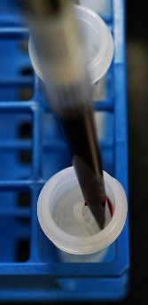

1. Cap each Smart Tube, and gently shake the tube while inverting several times to ensure complete mixing.

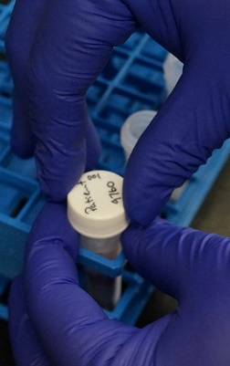

1. Incubate the Smart Tubes at 37°C for 15 minutes (use a water bath for best results).



1. Remove the Smart Tubes from the water bath and break the stabilizer-filled ampoule inside by squeezing and bending the tube.



1. Shake the tube gently, but firmly to mix the blood with the stabilizer.



1. Incubate blood with stabilizer for 10 minutes at room temperature.

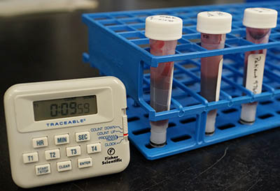

1. **Immediately** freeze the Smart Tubes at -80°C. If you cannot store the tubes immediately, keep them on ice until you can, but no more than 15 minutes. **Do not allow over-fixation!**

